FEE FINAL EVALUATION

Name: Abhay Gupta

ROLL: 2110991925

GROUP: G5

YEAR: 3rd

INSTRUCTOR: Lavish Arora

PROJECT TITLE: *NIKON*

NIKON, just like its name suggests, is a website where you can buy Nikon cameras called DSLRs. These are great for taking high-quality photos.

But NIKON doesn't stop there. They also have a bunch of extra things you can buy to make your camera even better. These extras are like special tools that help you take even more amazing photos.

So, if you want to get a Nikon camera or make your existing one even cooler, NIKON is the place to go. It's like a one-stop-shop for everything related to Nikon cameras and photography.

WHY NIKON?

Nikon has a long and impressive history of making really good cameras. I wanted to create a website that shows off how amazing their cameras are and what makes them special. This website is like a way of saying, "Nikon, you're awesome!"

I decided to make this website because I love photography, and I really wanted to make a place where people who love taking pictures could come together. It's a website made by a photography fan, for photography fans. So, it's like my way of sharing the passion with others who feel the same way about photography.

OVERVIEW

NIKON is a comprehensive website with a total of 20 different webpages, each serving a specific purpose or providing unique information. It's built using various technologies to make the website functional and attractive. These technologies include *HTML5*, which structures the content, *CSS3* for styling and layout, JavaScript for interactivity, *BootStrap5* for responsive design, and *Font Awesome* for cool icons and fonts.

If you're interested in exploring or contributing to the code that powers NIKON, you can find it on GitHub. Here's the link to the GitHub repository where the website's source code is stored: <https://github.com/AbhayG21/NIKON>

MAIN PAGES:

* Landing Page: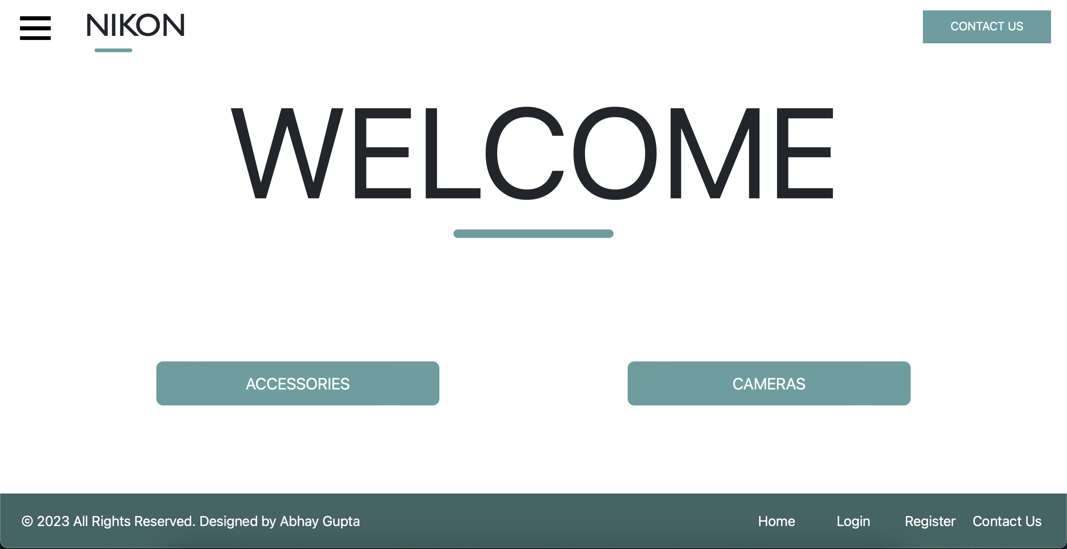
* DSLR INDEX PAGE: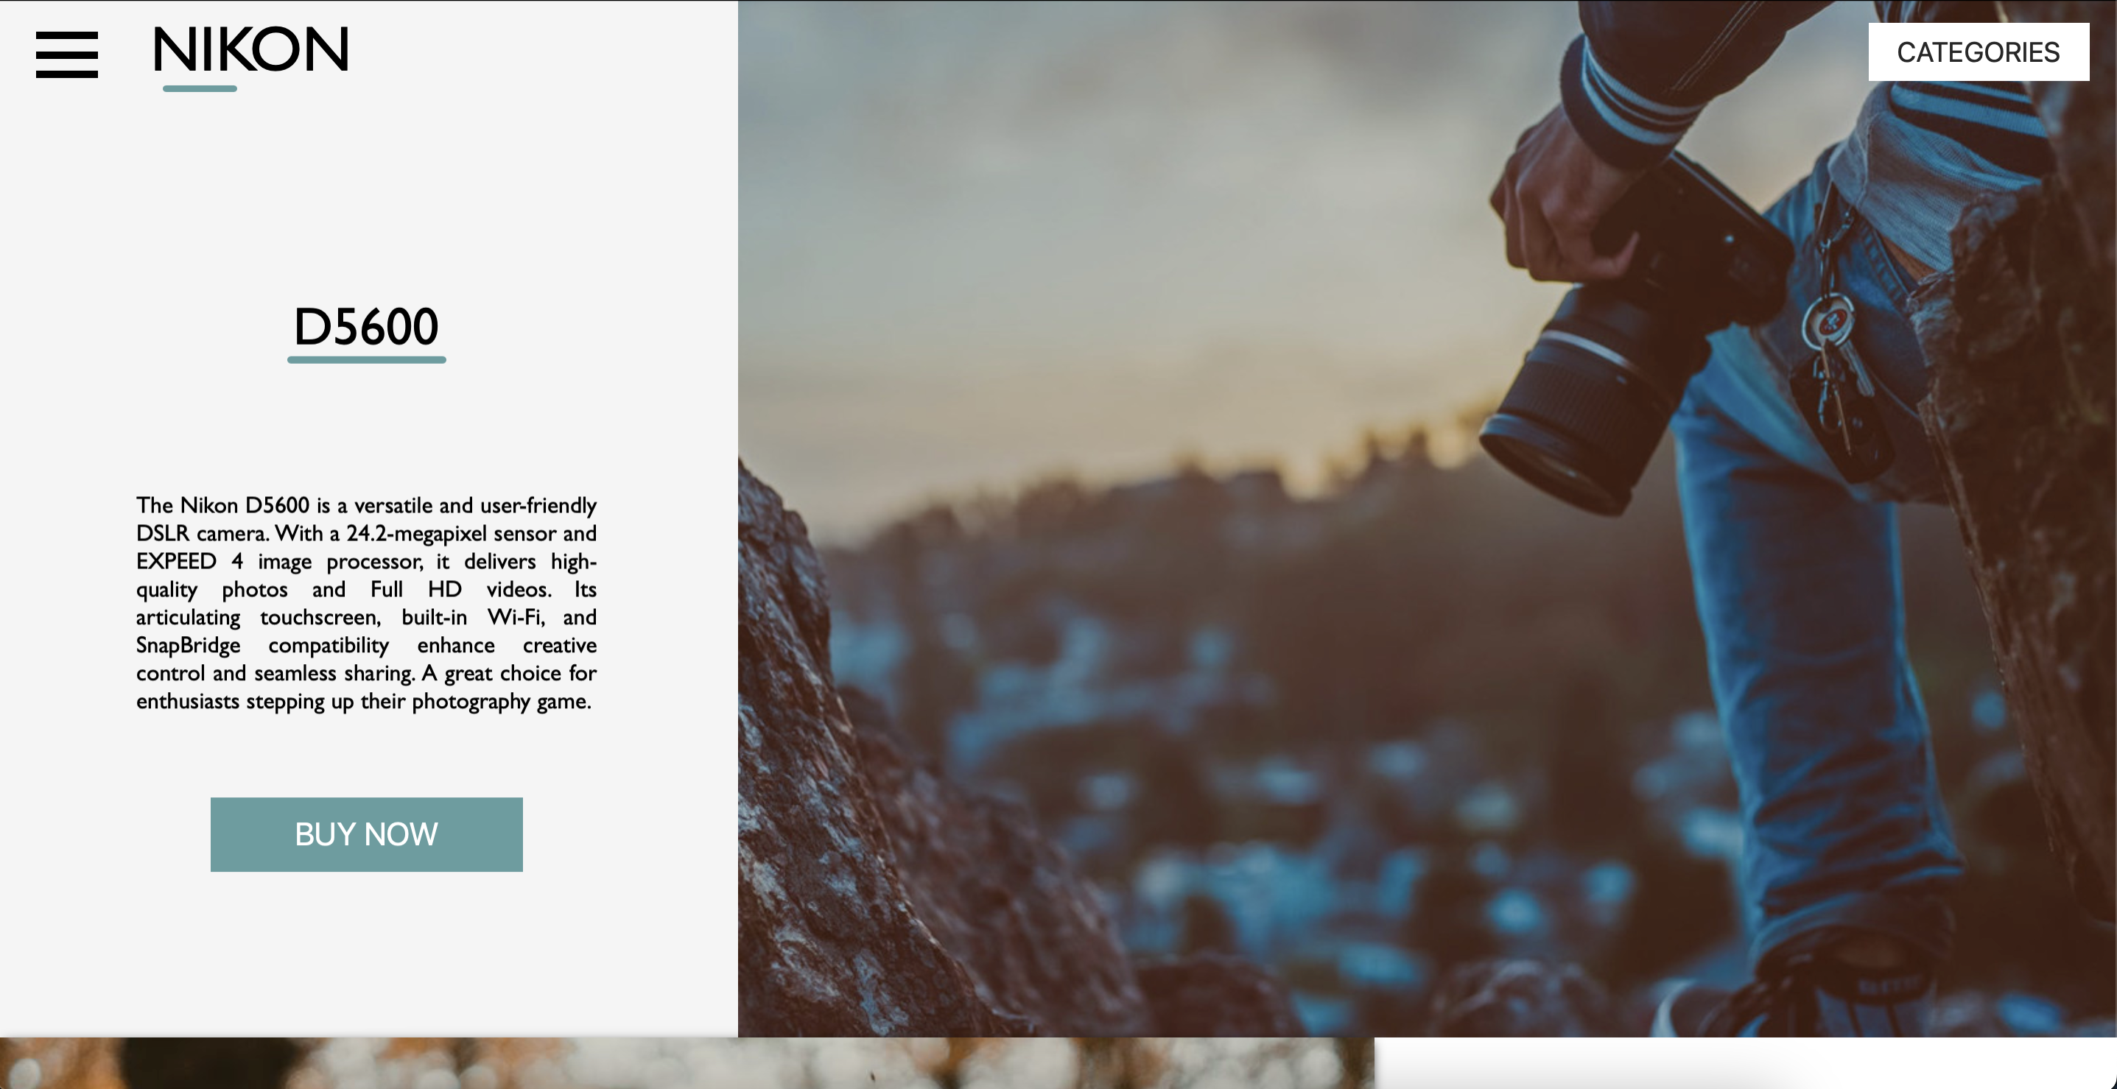
* ACCESSORIES INDEX PAGE: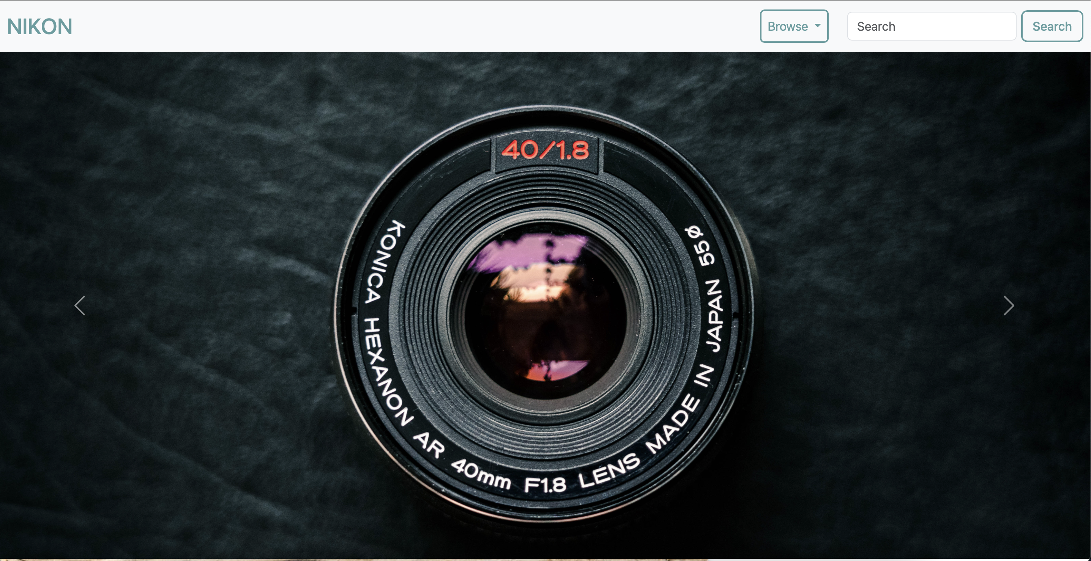
* CONTACT US: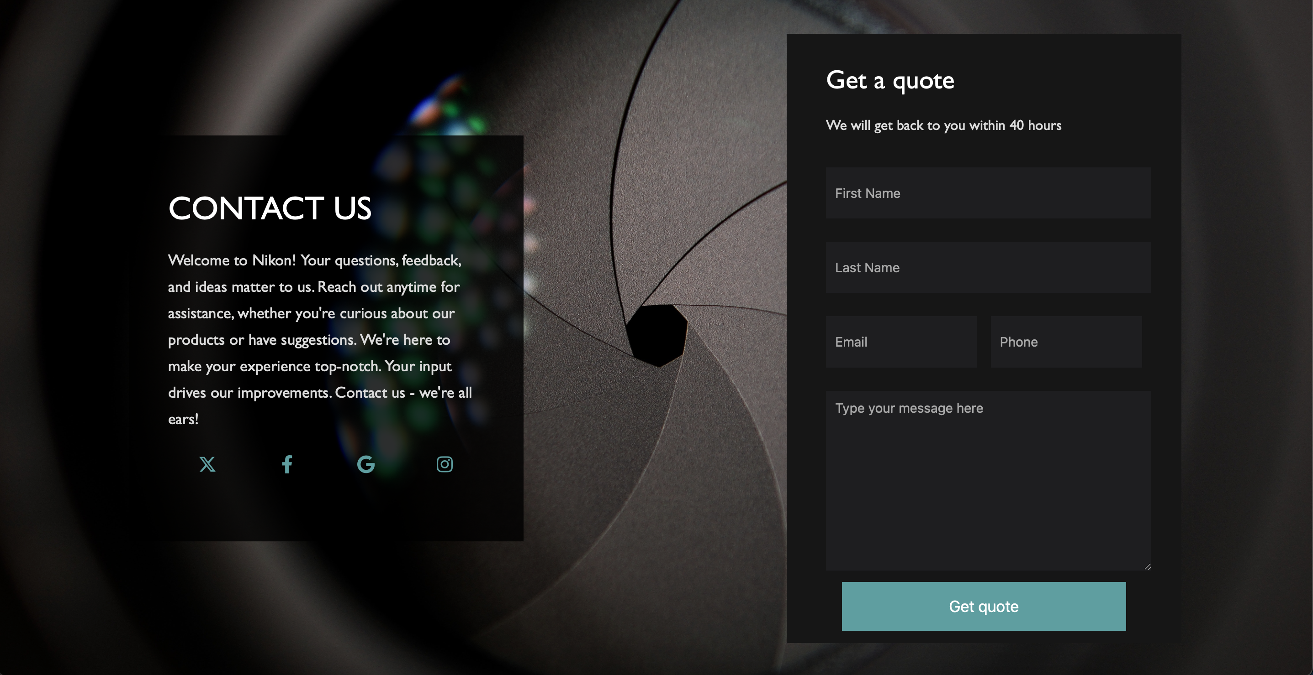

PROBLEMS FACED:

* Achieving Responsiveness: One of the main challenges we faced during the project was making sure the webpage looked good and worked well on all types of screens, like phones, tablets, and computers. Some of the things on the webpage moved around when we changed the screen size, and we needed to fix that.
* Improving User-Friendliness: We also focused on making the webpage more user-friendly, meaning we wanted to make it easier for people to use. We worked on optimizing the User Experience, which is all about how people feel and interact with the webpage. We wanted it to be a smooth and enjoyable experience for everyone.
* Using Bootstrap for Redesign: To help with these goals, we decided to use a tool called Bootstrap. It's a set of pre-made design elements and features that make it easier to create responsive and user-friendly webpages. We used Bootstrap to redesign certain parts of the webpage to make them work better and look nicer.
* Making Comparison page: Thinking about a way which would make the comparison page work was a challenge for me as it required a good knowledge of JavaScript and overcoming this hurdle was really exciting for me.
* Displaying info on Hover: Displaying information about core team members was a challenge and I solved it by creating 3 different datasets for the members and the person on whom the cursor is hovering, the dataset of that person gets displayed.

LEARNINGS:

* Building a Shopping Cart System on a Website:

Imagine you're making a webpage where people can shop for things. You want to create a system where they can add items to a cart, like when you shop in a store. This system will help users select and keep track of the items they want to buy.

* Swapping Images When Clicked:

Think about when you're on a website and you see a picture. You click on it, and the picture changes to show something else, like a different color or view of the product. That's what we mean by changing images on click. It's a way to give users a better look at what they're interested in.

* Revamping the Entire Set of Information on a Comparison Page:

Picture a webpage where you're comparing different products, maybe for buying a new phone. You can change the details, specs, and features of these products all in one place without having to go to different pages. It's like having a super handy comparison tool.

* Diving Deeper into HTML, CSS, and JavaScript:

When we talk about a "deeper understanding," we mean really getting to know these three things that make websites work.

* HTML is like the skeleton of a webpage. It structures the content, like headings, paragraphs, and links.
* CSS is the stylist; it controls how things look. It decides the colors, fonts, and layout.
* JavaScript: is the brain; it adds interactivity to the webpage. It can make things move, pop up, or change without needing to reload the page.

So, getting a deeper understanding of HTML, CSS, and JavaScript means you'll know how to make your webpages look good, work smoothly, and do cool things!

THANK YOU!!